

CST2120

**Web Application and Databases**

**Coursework 2 Final submission**

Ronuk Luchmonee (M00857843)

Damien Maujean (M00843707)

Dereck Lam Hon Wah (M00826933)

**Date of Submission: 17.12.22**

**Lab Tutor: Mrinal Sharma**

Table of Contents

Table of Figures 2

Introduction 3

E-commerce (Client-side) 4

Common Elements 4

Homepage (client/index.php) 5

Account page (client/account.php) 11

Basket page (client/cart.php) 11

Login page (client/login.php) 13

Registration page (client/registration.php) 15

Content Management System (CMS) 18

Login Page (cms/login.php) 19

Login Function 19

Interactive text 19

CMS main page (cms/index.php) 20

Data filtering bar 22

Remove product and order. 23

Add Product 23

Edit product. 24

Security, Privacy and Legal Issues and how they can be fixed? 25

Security 25

DDoS Attack: 25

SQL and NoSQL Injection attacks: 25

Physical Attacks: 25

Privacy 26

Data collection: 26

User activity tracking: 26

Data Breaches: 26

Legal 26

Personal Data: 26

# Table of Figures

Figure 1 Navigation (No user logins) 4

Figure 2 Navigation (User logins) 4

Figure 3 Footer 5

Figure 4 Hero 5

Figure 5 Catalog (Default) 6

Figure 6 Catalog (Products added to cart) 7

Figure 7 Catalog (Searching Functionality) 7

Figure 8 Catalog ( Sorting: A-Z) 8

Figure 9 Catalog (Sorting Z-A) 8

Figure 10 Catalog (Search and Sort Functionality) 9

Figure 11 HTML Session Storage 9

Figure 12 Recommendation (Default) 10

Figure 13 Recommendation (Cart Category) 10

Figure 14 Account (User Details) 11

Figure 15 Account (View Past Orders) 11

Figure 16 Cart 12

Figure 17 Cart (Order Confirmation Message) 13

Figure 18 Cart (Order Confirmed Message) 13

Figure 19 Login (default) 14

Figure 20 Login (Incorrect Details) 15

Figure 21 Login (Success) 15

Figure 22 Registration (default) 16

Figure 23 Registration (Info missing) 17

Figure 24 Registration (Password not matched) 18

Figure 25 Registration (Confirmation message) 18

Figure 26 Login 19

Figure 27 Login (unauthorized error message) 20

Figure 28 Login (Incorrect credentials) 20

Figure 29 List of products 21

Figure 30 List of orders 22

Figure 31 Product Filter 22

Figure 32 Order Filter 22

Figure 33 Remove order 23

Figure 34 Add product 24

Figure 35 Edit Product 24

# Introduction

The design and development of this e-commerce website was a success with the implementation of various technologies such as HTML, CSS, and JavaScript as frontend programming languages, PHP as backend programming languages, and MongoDB as the database. jQuery and jQuery UI were the main libraries used to simplify a lot of complicated implementations from JavaScript, like AJAX calls and DOM manipulation.

The e-commerce website adopted a minimalist web design to simplify the interface and remove unnecessary elements or content for more user readability and functionality. This website is a fruit-e-commerce website composed of a client-side where the clients will order their products and may edit their customers' details and a content management system (CMS) where only admin access users will manage the products and orders.

# E-commerce (Client-side)

## Common Elements

The navigation and footer are the common elements with similar functionalities found on the different web pages. The navigation consists of a list of the pages' links to redirect the user to specific web pages such as home, catalogue, basket, and account web pages. Moreover, a login link will redirect the user to the login page for existing users or the registration page for new users. When the navigation bar loads, it accesses the PHP session variable values "loggedIn" to check if a user is currently logged in and toggle from the login to logout link and functionality. The logout link will remove all session variables and destroy the session meaning no user is currently login and toggle the login link back.

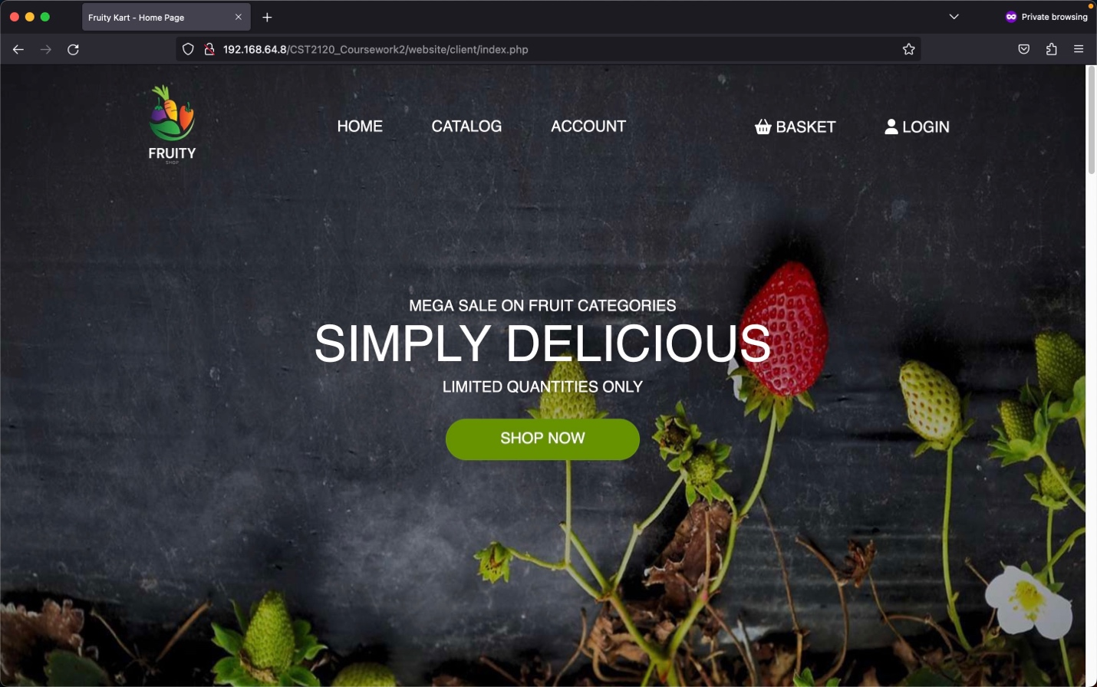

Figure 1 Navigation (No user logins)

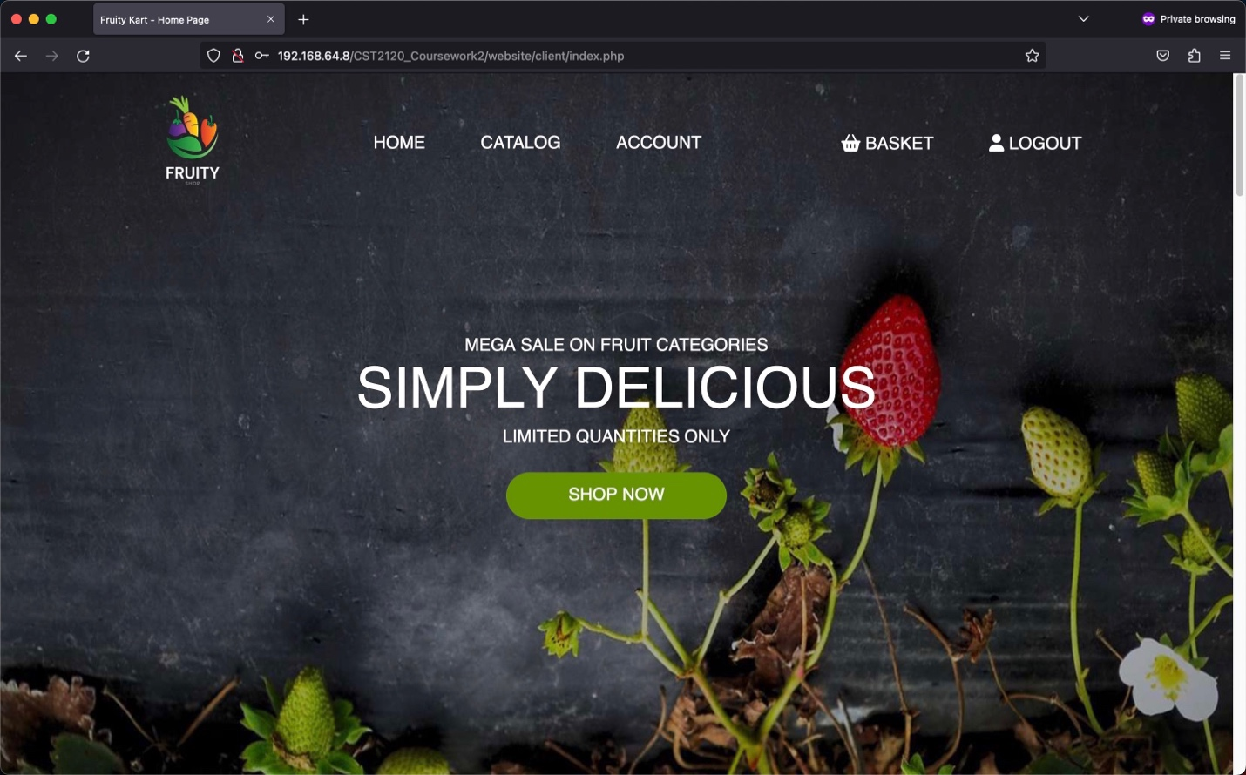

Figure 2 Navigation (User logins)

The footer consists of different social media links, contact information, and quick links to access a specific section of a specific web page. Moreover, if no user is currently login, the user will only have access to view the catalogue and add to cart but won't have access to the cart for checkout and account page.

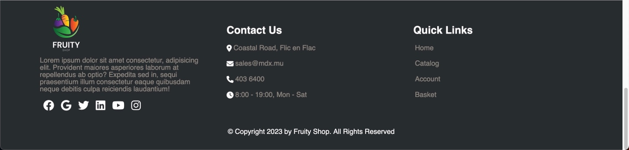

Figure 3 Footer

## Homepage (client/index.php)

The homepage consists of three main sections: the hero, recommendations, and a catalogue with their respective functionalities.

The hero section will redirect the user to the catalogue section, where the user can view the different fruits available for sale.

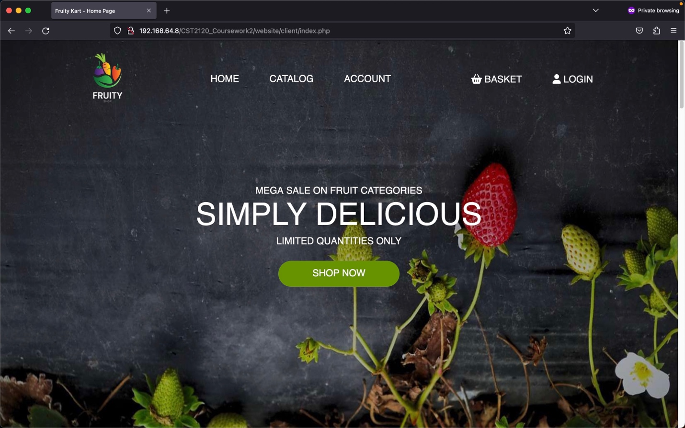

Figure 4 Hero

The catalogue's items are loaded through an ajax request, which retrieves all the documents in the "products" collection to create each product's container HTML elements. From the catalogue section, the user will click on the "Add to cart" button, which will send an ajax request to retrieve the product's details from the "products" collection and store it in an array in the HTML session storage "cart" key. It will toggle to a "remove to cart" button when clicked, removes the specific product from the HTML session storage, and toggle the button to "add to cart." The search and sorting functionalities in the catalogue improve the user experience when scrolling through the list of available items. The search functionality rebuilds the catalogue section by performing a text search on the "products" collection with a text index that can take a keyword from the user input and looks for matches. Each time the user executes a successful search, it stores the user input keyword in an array in the HTML session storage "search" key. The user can sort the catalogue item section in ascending, descending, and default order (product id) based on the product names.

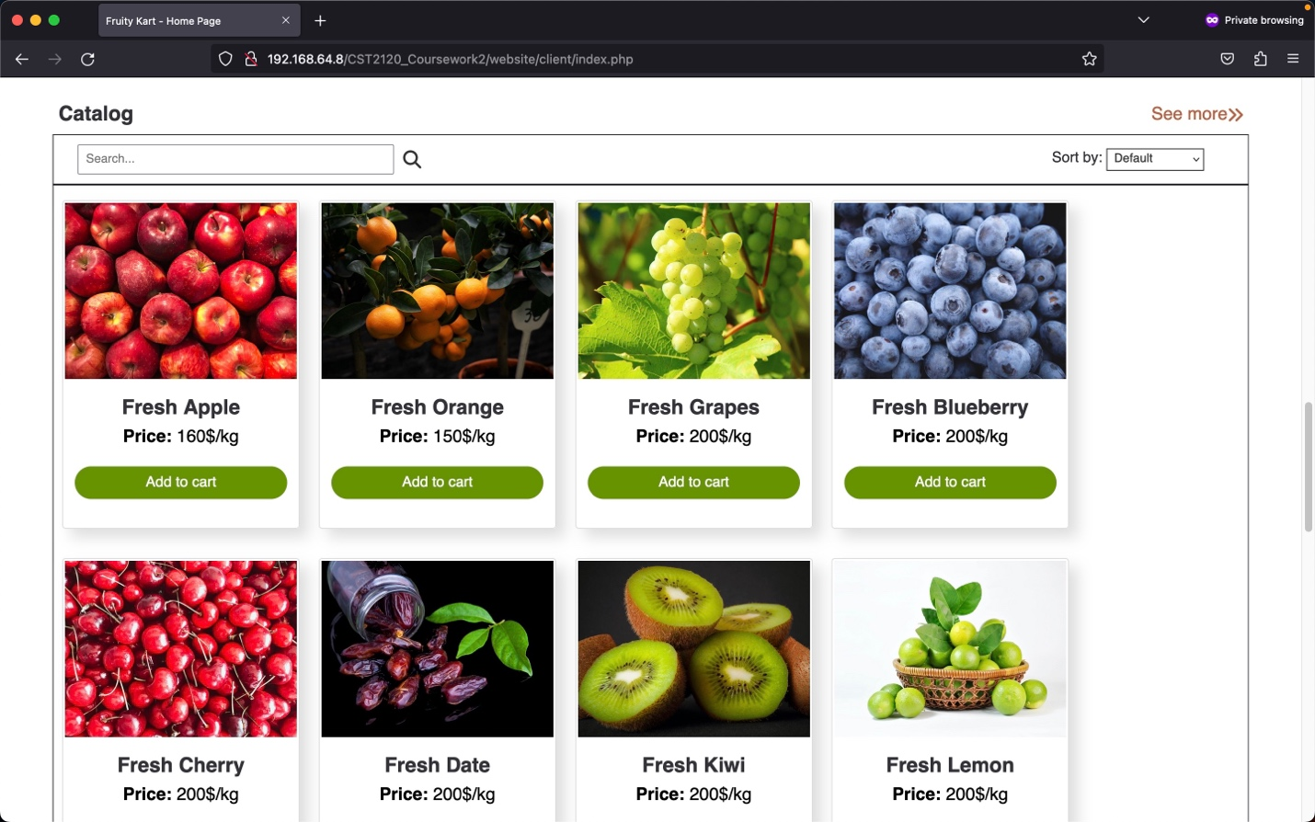

Figure 5 Catalog (Default)

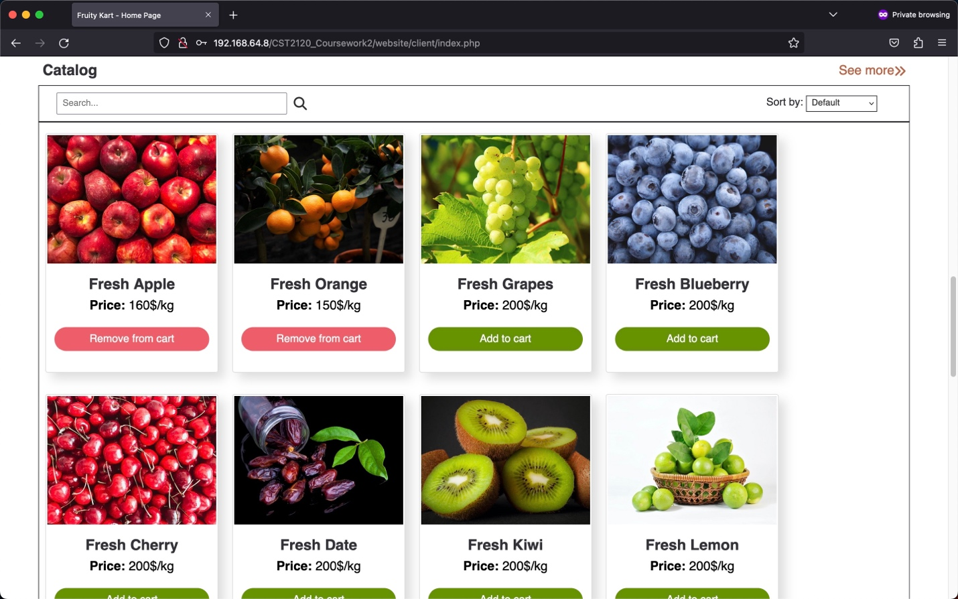

Figure 6 Catalog (Products added to cart)

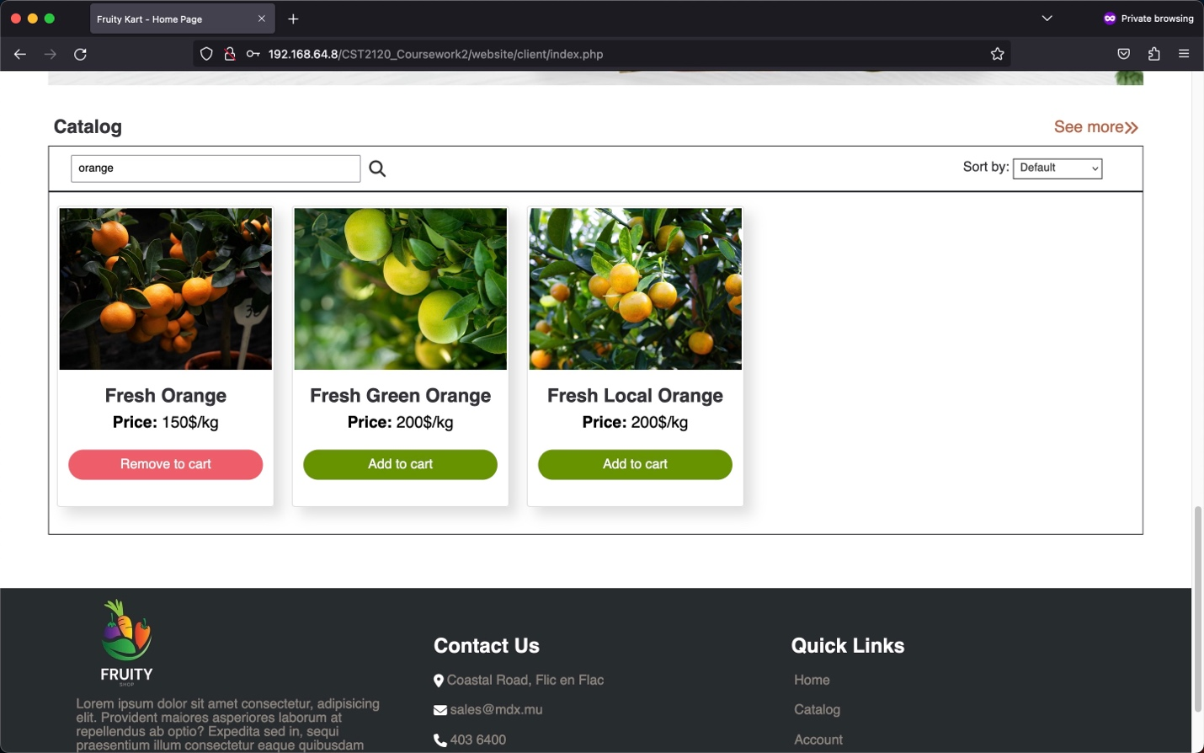

Figure 7 Catalog (Searching Functionality)

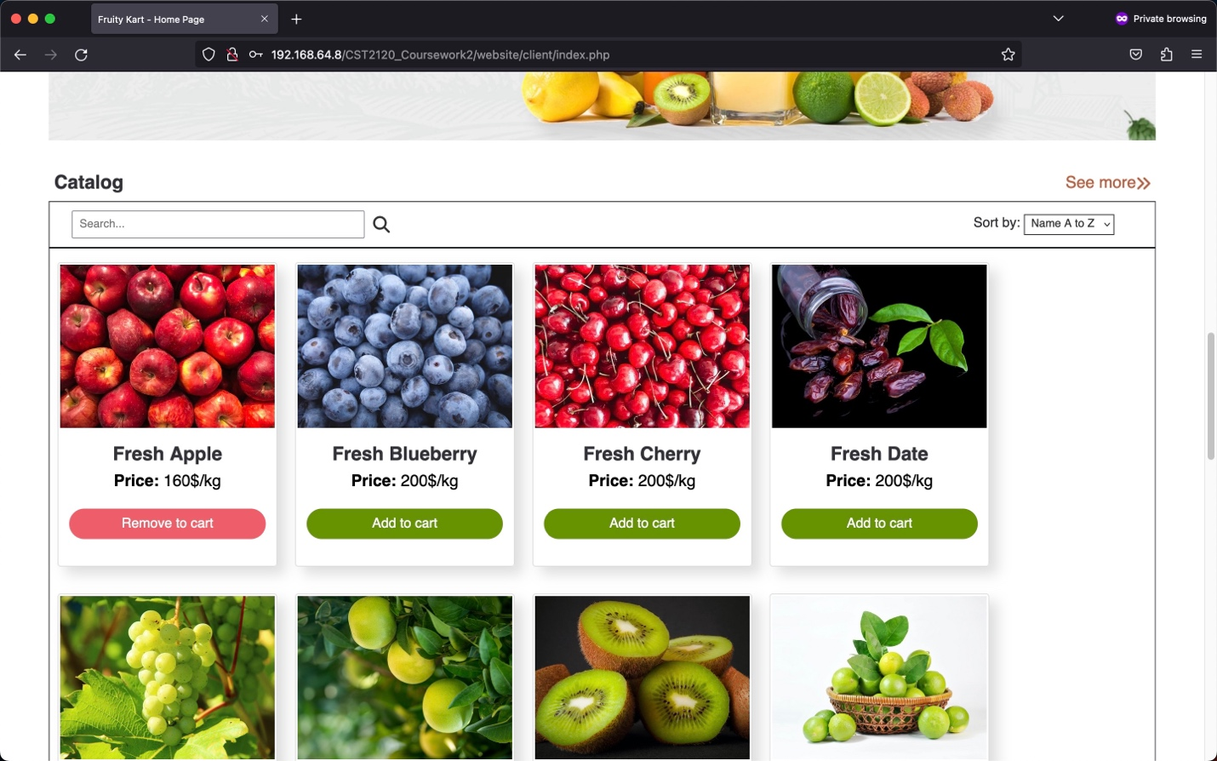

Figure 8 Catalog (Sorting: A-Z)

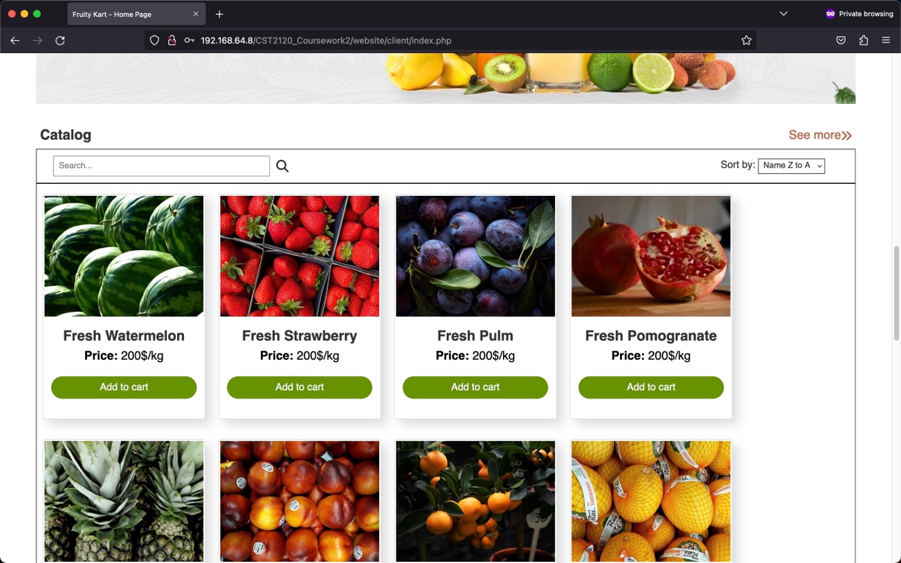

Figure 9 Catalog (Sorting Z-A)

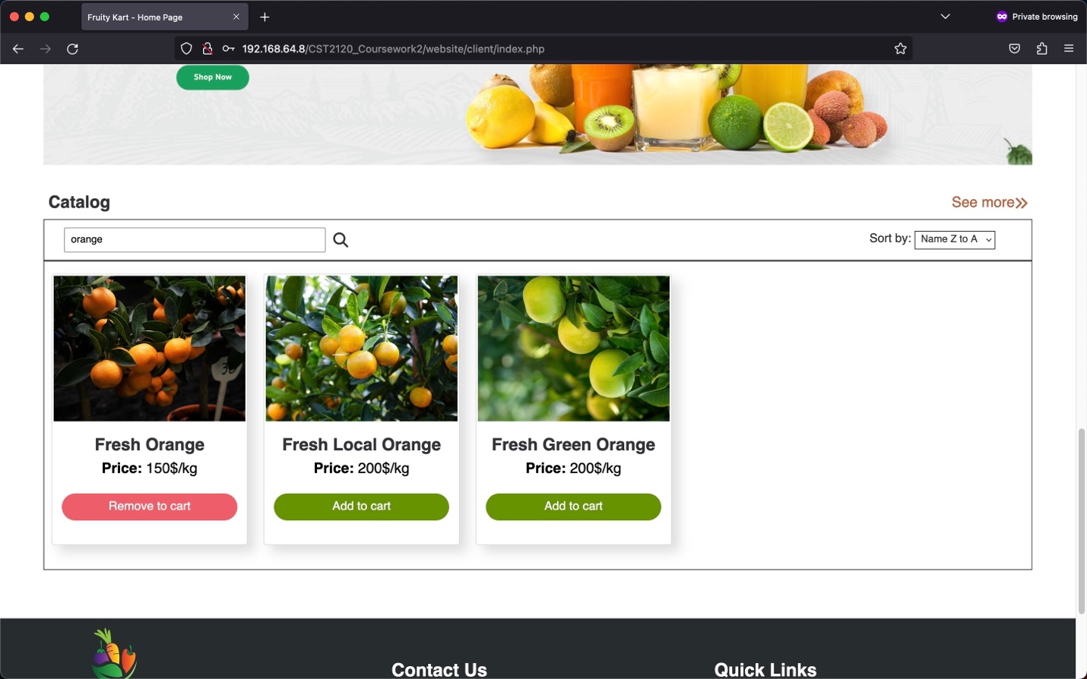

Figure 10 Catalog (Search and Sort Functionality)

The recommendation section will retrieve 1-4 products through an ajax request from mongo DB based on three types of recommendations from the user product's search and products currently in the cart on the e-commerce website. These details are stored in the HTML session storage in their respective arrays. If the user has not done any search and has no products stored in the cart, the recommendation will display four products based on their product id. If the HTML session storage "search" key has some values and the "cart" key is empty, the recommendation section bases itself on the most occurrence of the user search input. If both keys have some values, the recommendation functionality will display the category of products currently most added to the cart. If the "search" key is empty and the "cart" key has some values, it will take into consideration a recommendation based on the category of product in the cart as well.

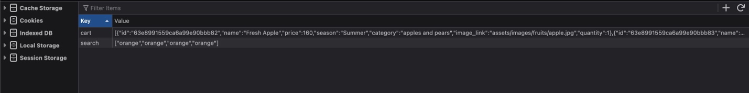

Figure 11 HTML Session Storage

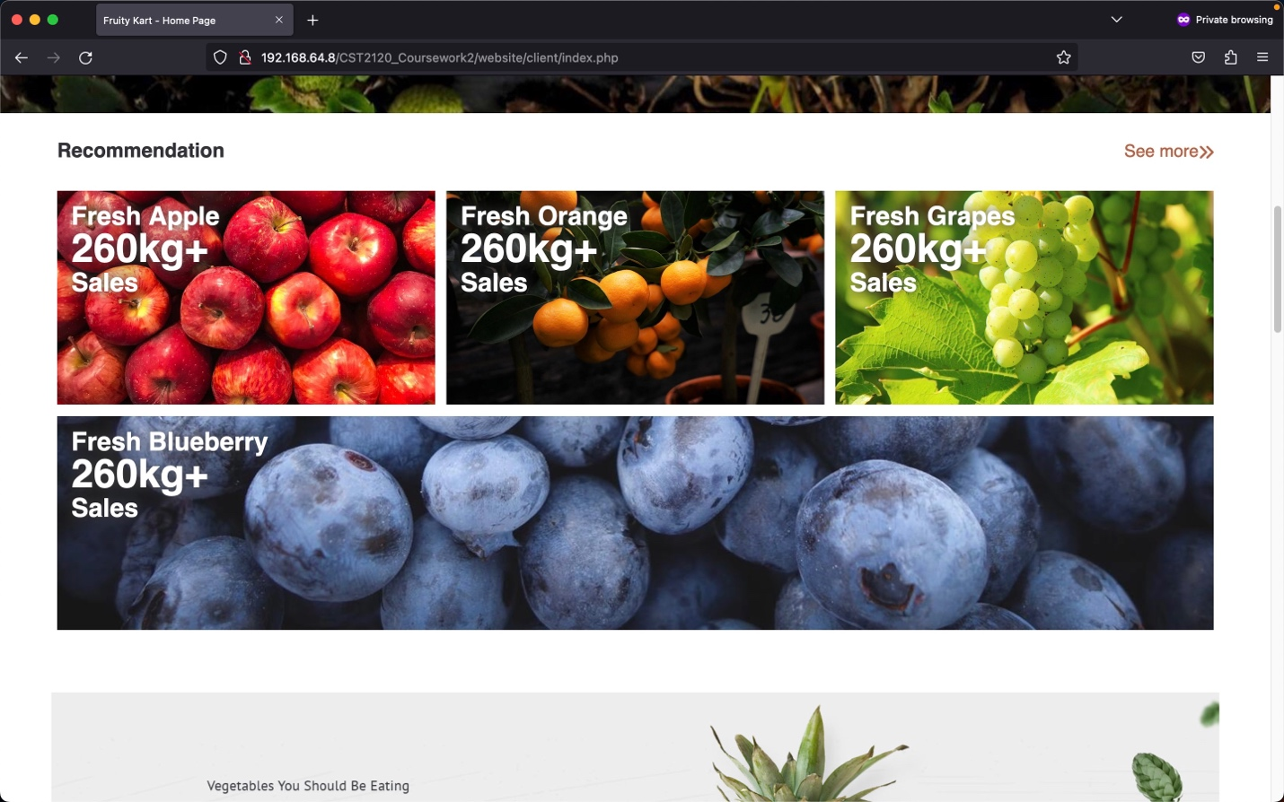

Figure 12 Recommendation (Default)

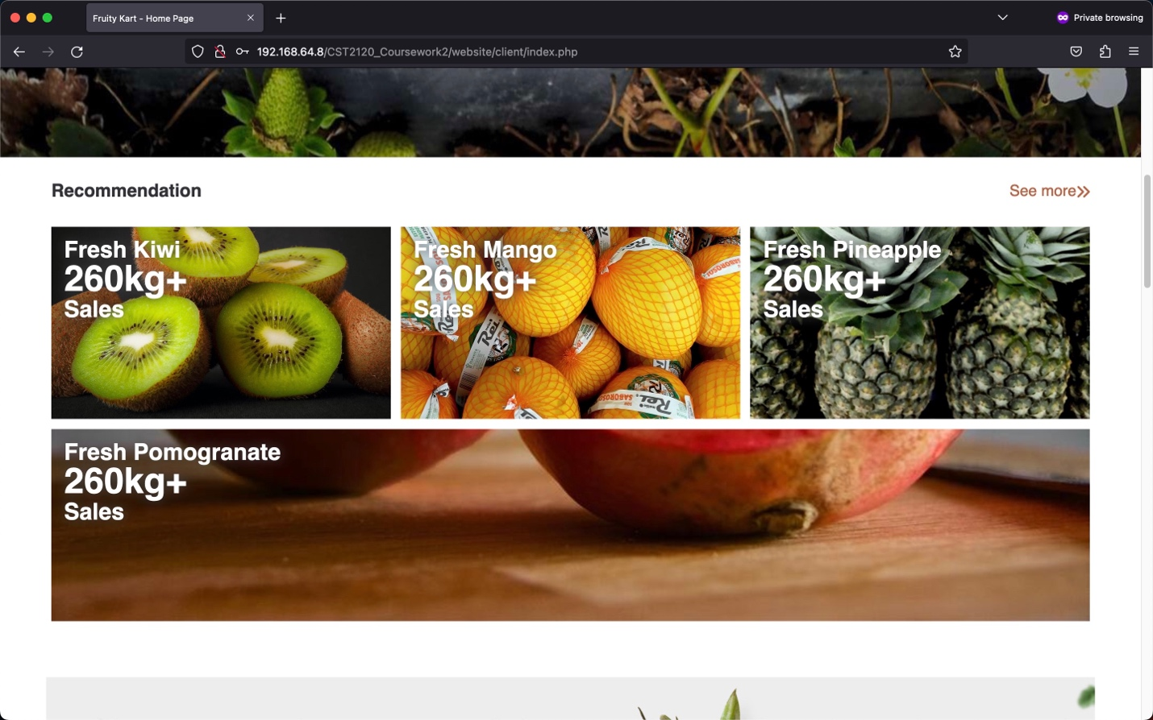

Figure 13 Recommendation (Cart Category)

## Account page (client/account.php)

The account page consists of two sections: user personal information and history of past orders.

User personal information section will display the current customer info retrieved from mongodb and will give access to the login user to change details like name, surname, email, phone, and address. When the user closes the jQuery UI edit account dialog, another ajax request is send to display the updated information on the account detail section.

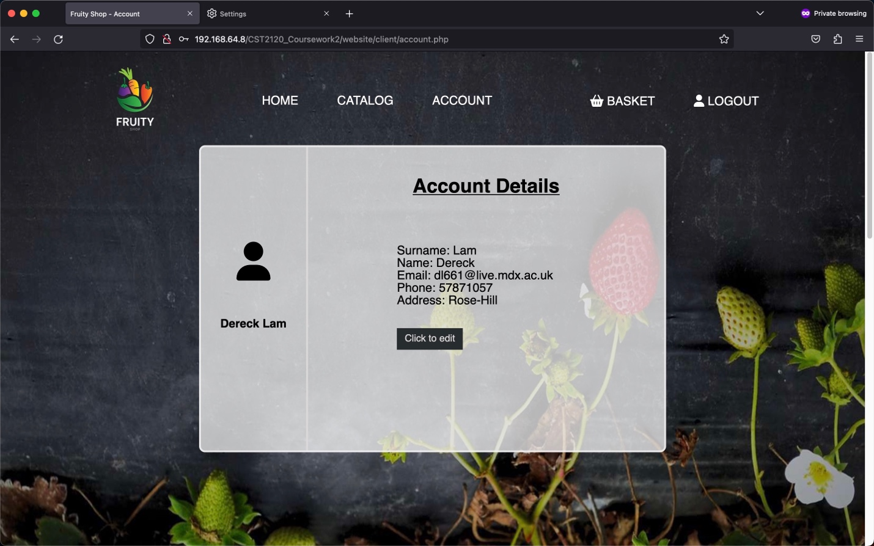

Figure 14 Account (User Details)

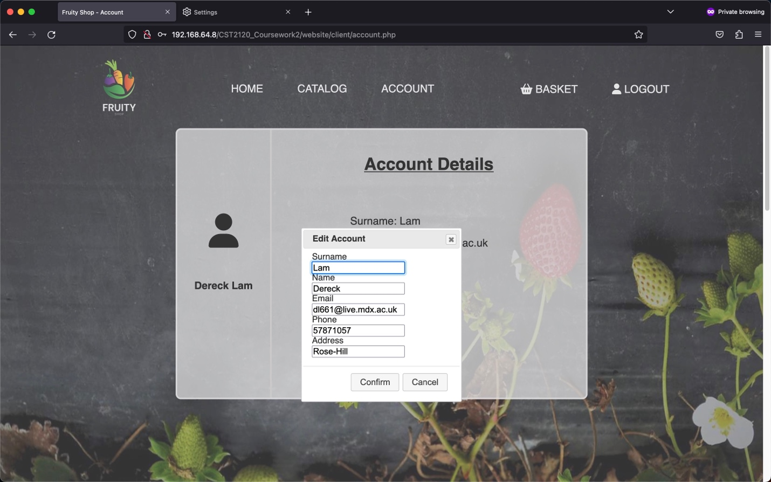

Figure 15 Account (Edit customer details)

History of past order will display only the orders checkout from the currently login user. Once the html document finished loading, an ajax request is send to retrieve the order list with the currently login id stored in the PHP session storage.

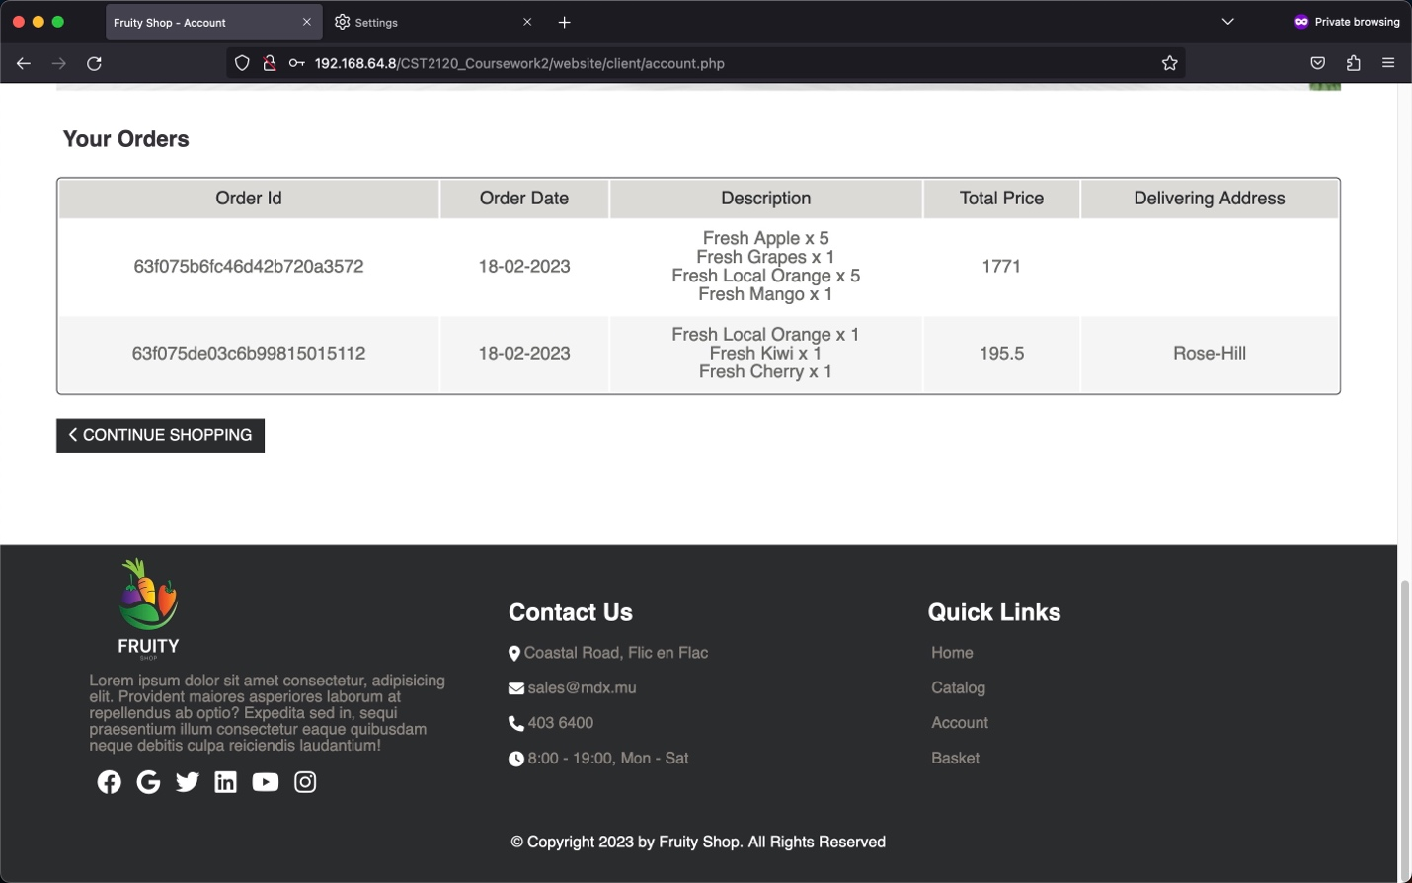

Figure 16 Account (View Past Orders)

## Basket page (client/cart.php)

The cart page consists of two sections: details of the items in the cart and a price summary of the total order. The user can increase/decrease the item's quantity or remove it from the cart, which will change the value of the HTML session storage "cart" key. Any changes made will send an ajax request to rebuild the cart, making it dynamic as the web page won't refresh. By default, the quantity of any item added to the cart will hold "1" as the value. If any item's quantity value changes and the user go to another webpage, the HTML session storage has already recorded the changes and, the user returns to the cart page, which will display the correct item's quantity. The max quantity of items available to be ordered is checked from the number of items available in stock from MongoDB. Moreover, any changes in the item in the cart will amend the total order price summary and await the user to checkout or log out. At the end of the cart section, the user can either continue shopping or checkout to confirm the order. jQuery UI helps to display the checkout confirmation message which if approved, redirects the user to the homepage and sends an ajax request to store the order details to the collection "orders" in MongoDB or else just closes the confirmation message.

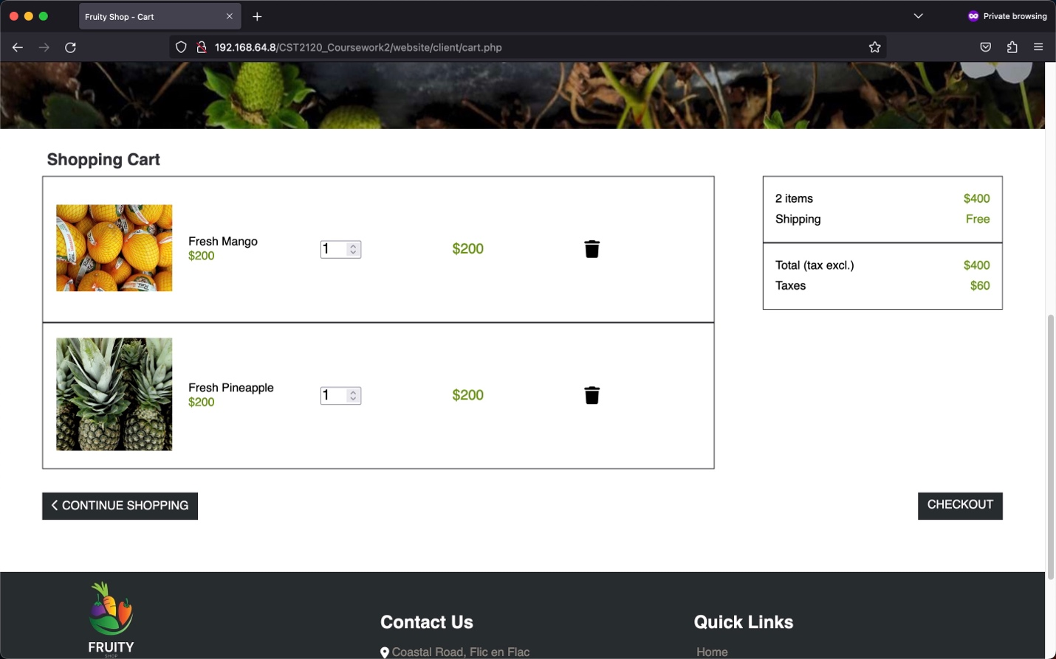

Figure 17 Cart

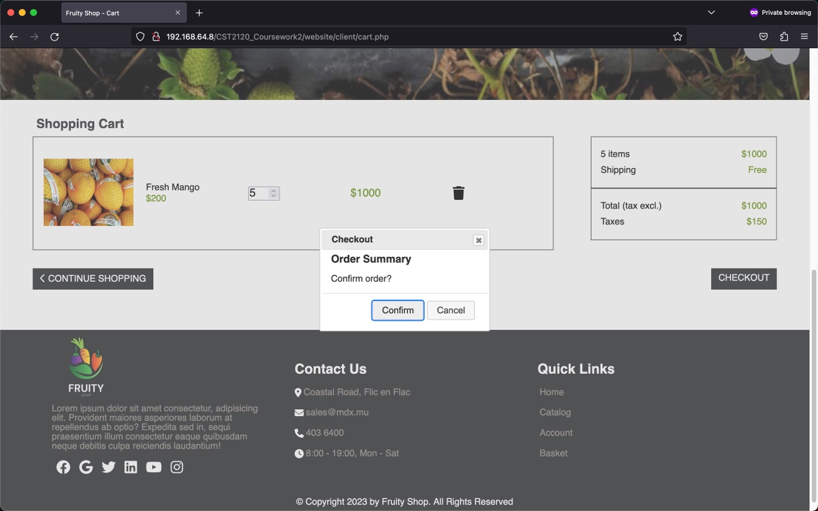

Figure 18 Cart (Order Confirmation Message)

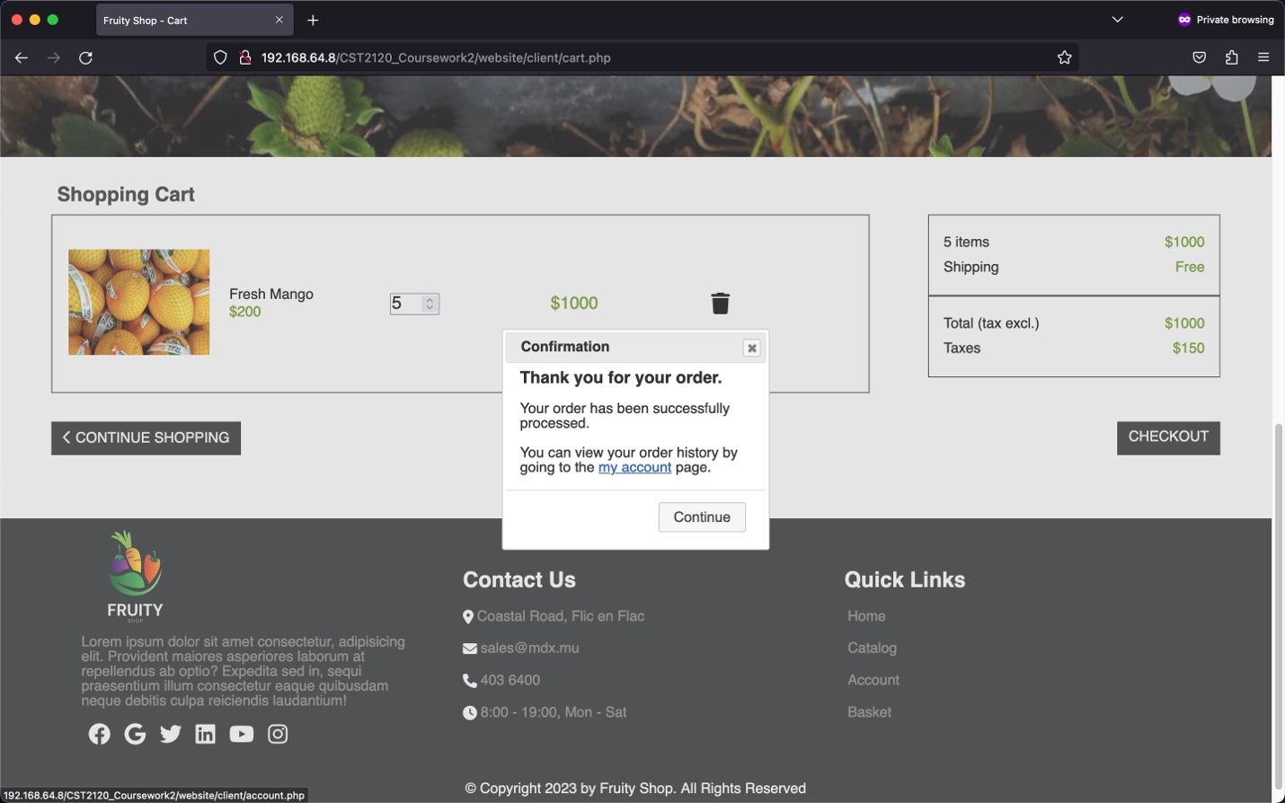

Figure 19 Cart (Order Confirmed Message)

## Login page (client/login.php)

The login page is essential for the user to check out his order and view his personal details and history of past orders. The user will submit his registered email and password, which send an ajax request to check if the email exists in the MongoDB "email" collection and if the password matches the registered email's password.

1. Checks if the email address and password are empty.
2. Checks if the email address inputted matches any email address found in the MongoDB "users" collection.
3. Checks if matched email address's password in MongoDB's "users" collection matches with the inputted password.

The website will display the proper error/correct message using JQuery UI to advise the user on the login status. If the user successfully logins, the user id is stored in the PHP session storage “loggedIn” key and the web page is redirected to the homepage.

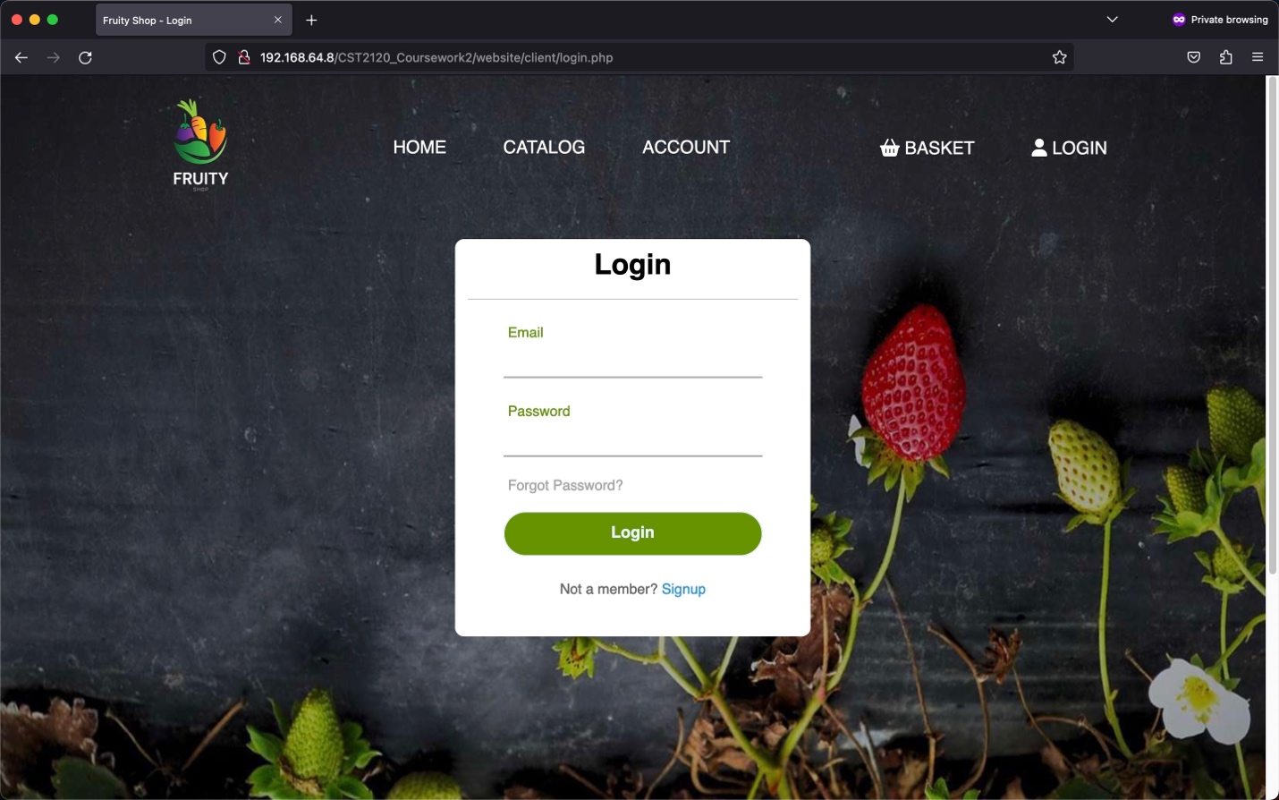

Figure 20 Login (default)

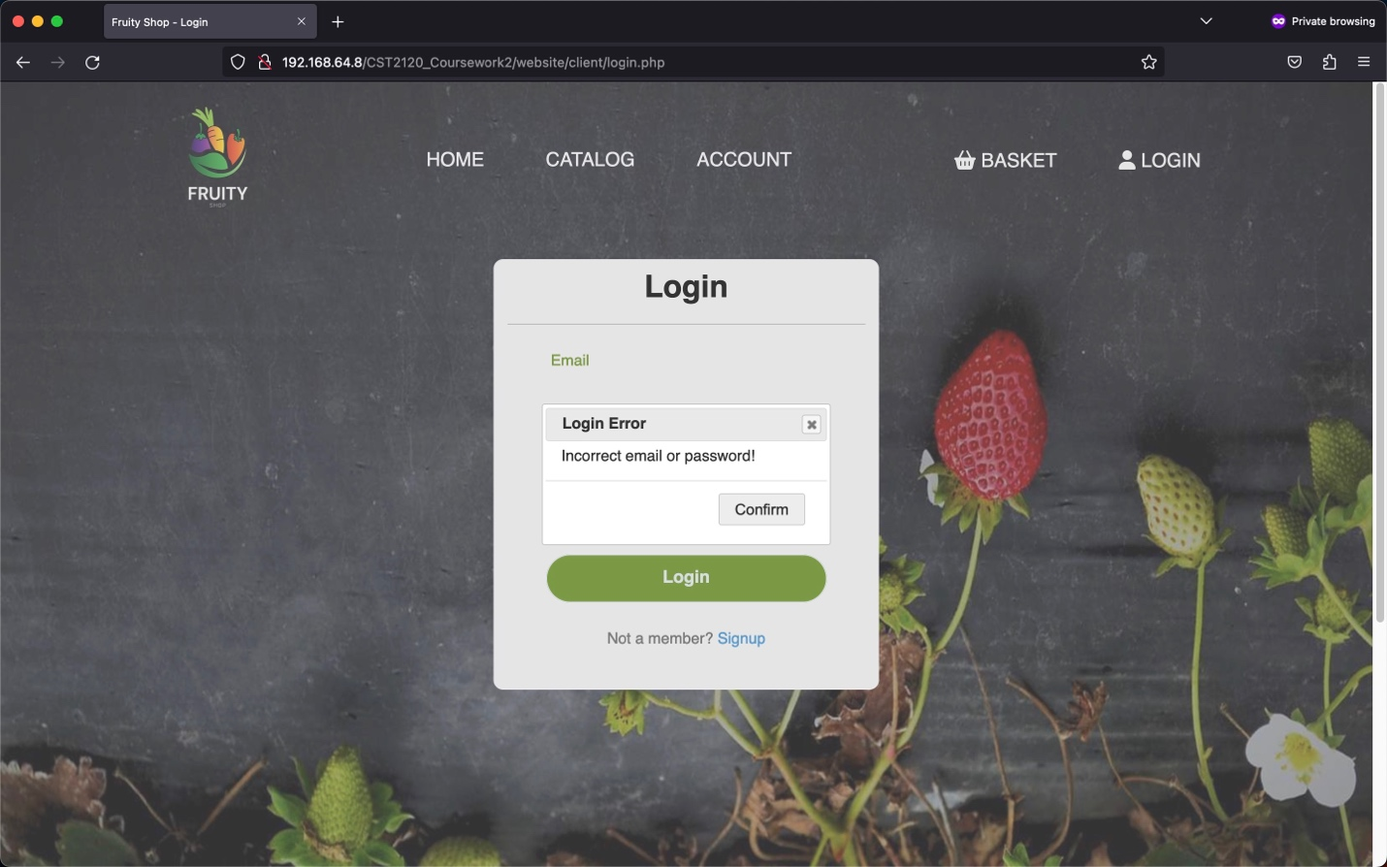

Figure 21 Login (Incorrect Details)

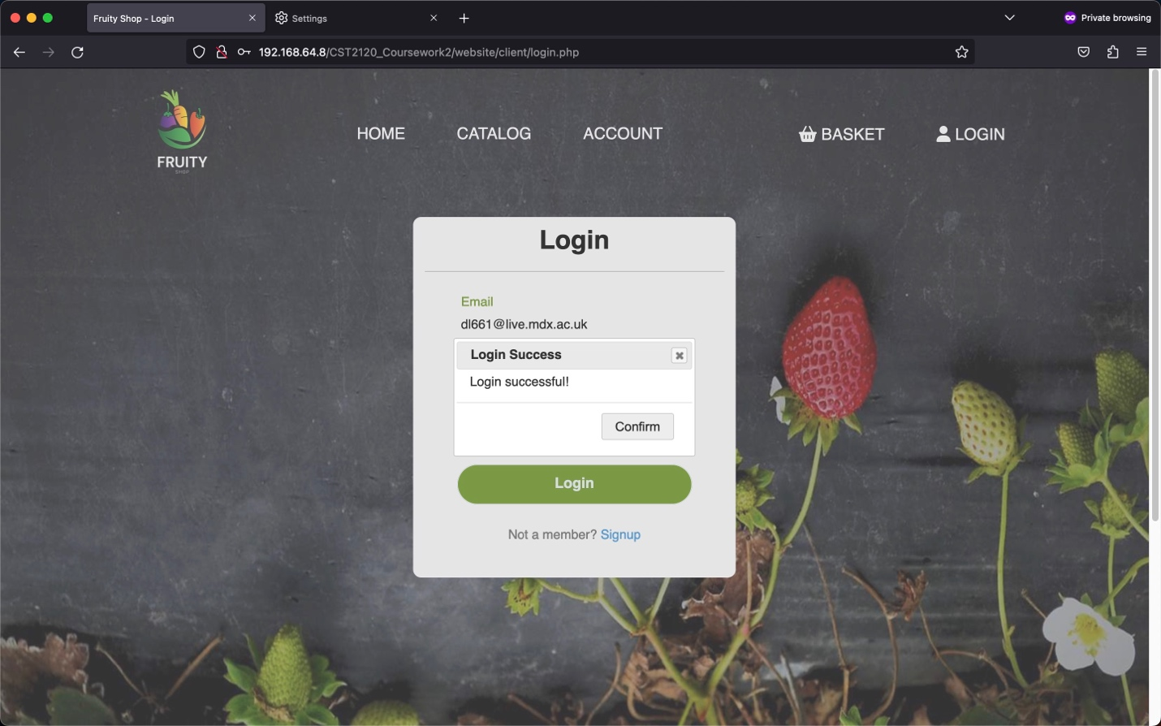

Figure 22 Login (Success)

## Registration page (client/registration.php)

The registration page will store the client's details by filling an HTML form that performs the basic check through javascript or regular expressions. The validations are as follows:

1. Check if the email address is a string separated into two parts by a @ symbol and a domain.
2. Check password should have at least 8 characters.
3. Check retype password matches the password entered above.

After the form validation, an ajax request is sent to insert a document in the MongoDB "users" collection to store the user's details for login and customer tracking.

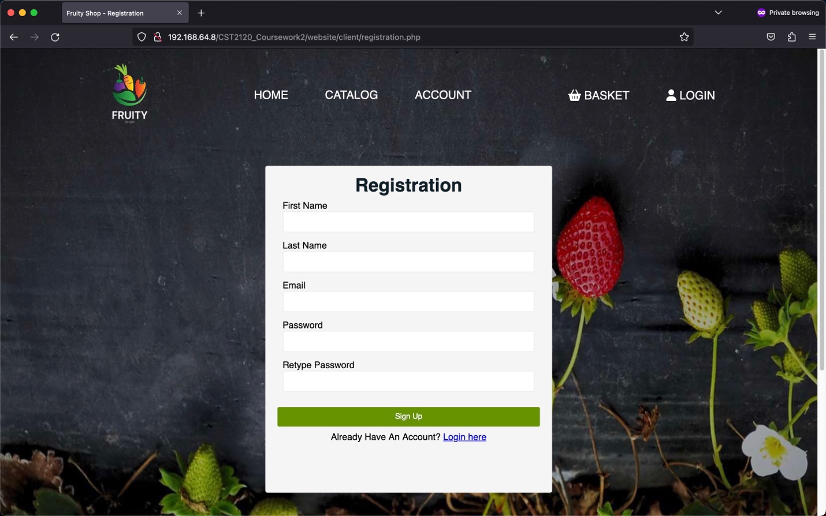

Figure 23 Registration (default)

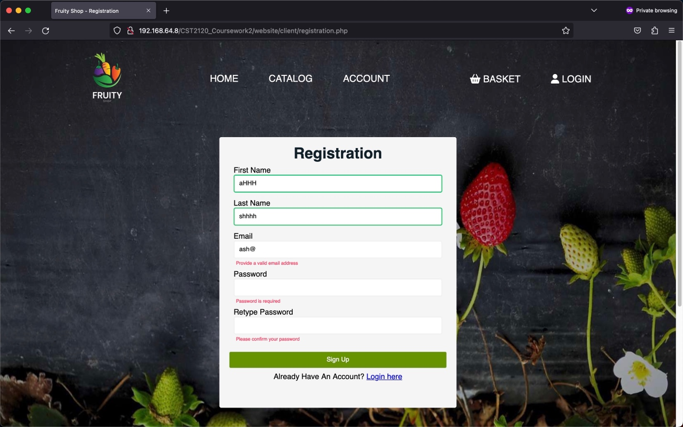

Figure 24 Registration (Info missing)

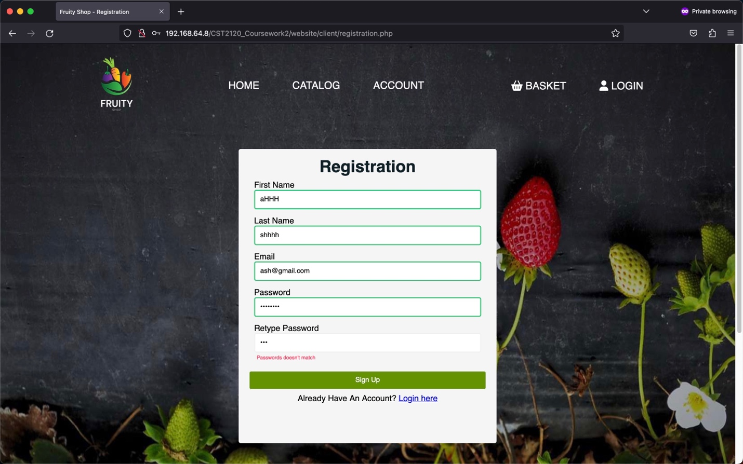

Figure 25 Registration (Password not matched)

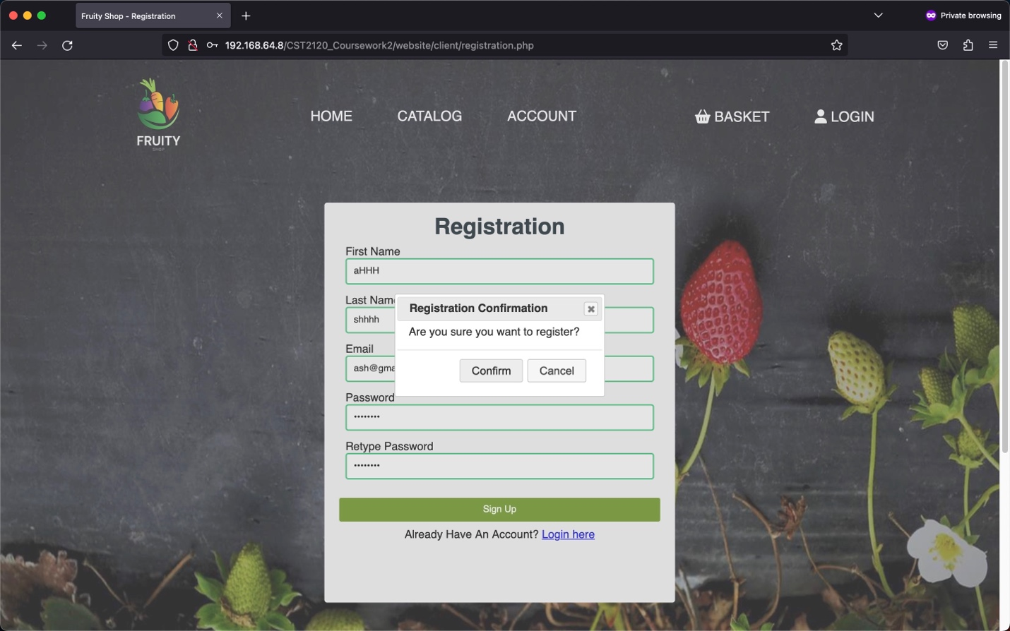

Figure 26 Registration (Confirmation message)

# Content Management System (CMS)

The CMS is a tool for the staff and the authorize people only to have unlimited access to the database and change, add or remove some data from it. It is secured by a login verification to allow only the authorized staff and is an important feature of our ecommerce website.

## Login Page (CMS/login.php)

The Index.php page which is the first page of access to the CMS is the login page to allow the user to fill his credentials and access if authorize to the main CMS page and all his functionalities such has list all the products and orders, and/edit product, search in the product and order and finally cut element in the database.

### Login Function

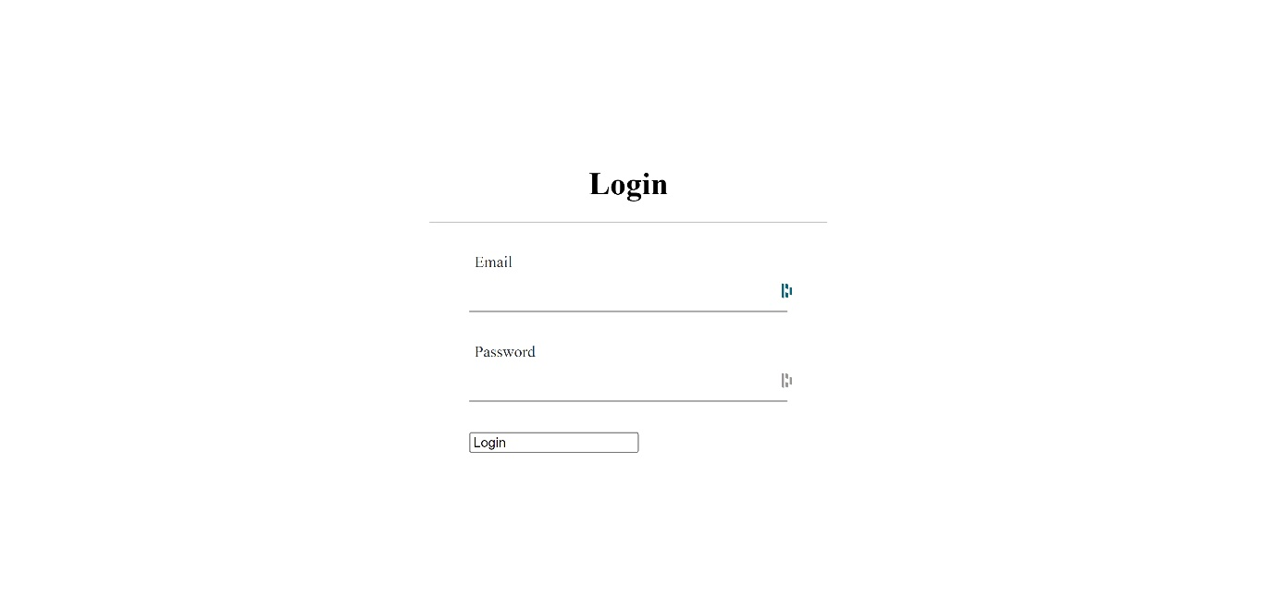

Figure 27 Login

The login page is composed of two input fields for the email and the password of the user and a login button. When the login button is pressing a JavaScript function is trigger and get the different field input to send to the post.php file by html post method using ajax to find the corresponding user in the table “users” in the database. When the result of the query is returned, if no user was found with the email and password entered by the user, a message “Incorrect Password” or “Email does not exist” will be sent back to the JavaScript file. If a user is found, it will check the category of the user (“admin” or “customer”) and return “Unauthorized” if customer or “Login Successful” if admin.

### Interactive text

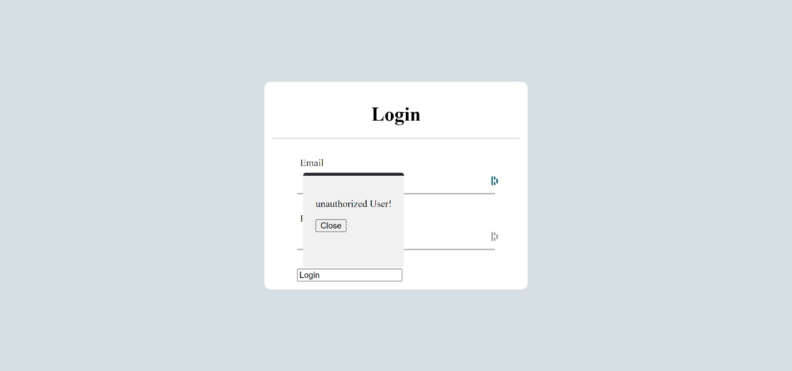

Figure 28 Login (unauthorized error message)

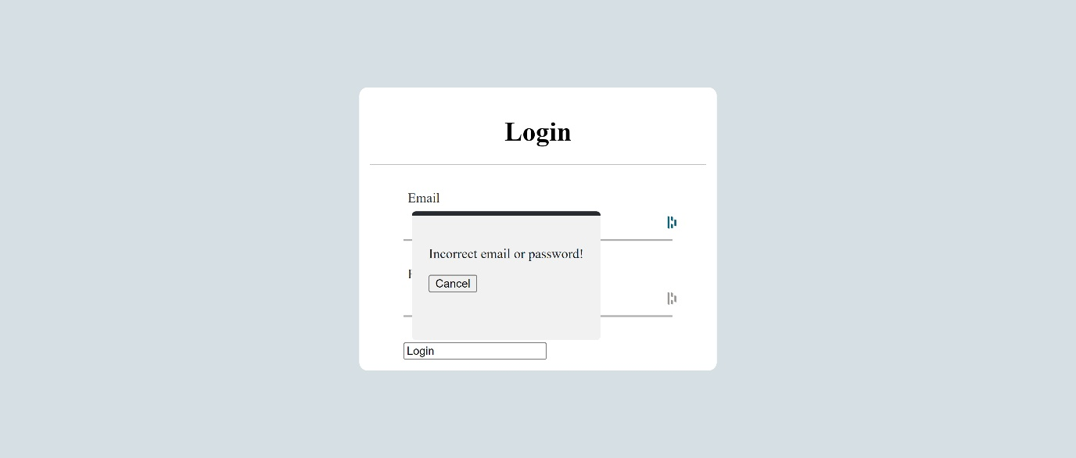

Figure 29 Login (Incorrect credentials)

When the connection with the database returns the result is returned, the proper jQuery dialog appears in the screen displaying the right error message. If the result is a successful login, then the user will be redirected to the main CMS page.

## CMS main page (CMS/index.php)

The CMS main page is composed of two consistent parts, the left vertical menu with button: “List Product”, “List Orders”, “Add Product” and “Remove Product”. Then on the right is the container with on the top some filtering option and at the bottom a table to display the different data gathered from the database.

#### List products and orders

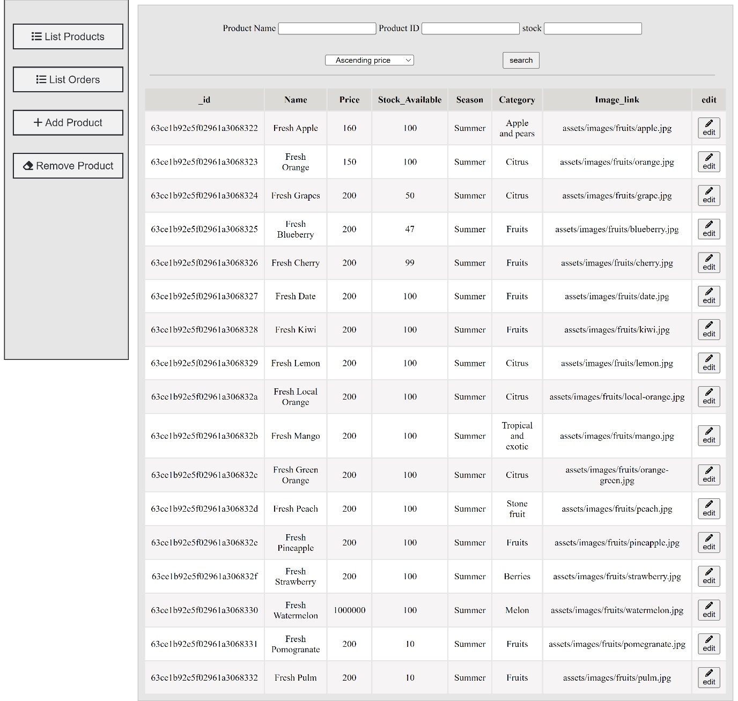

Figure 30 List of products

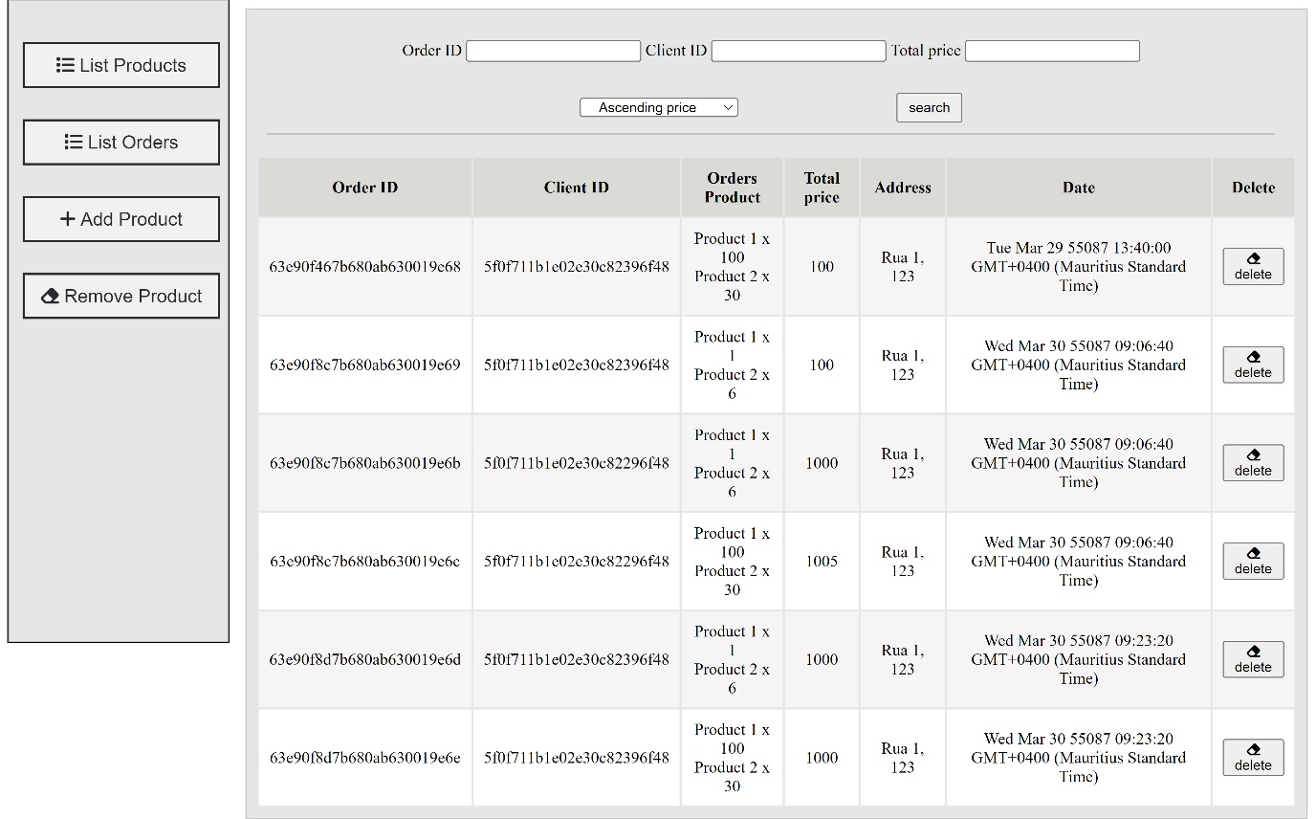

Figure 31 List of orders

The “List Products” and “List Orders” button will have their name say, display the different data wanted from the database. When pressed, some action will be taken, firstly it will change the text of the filtering field using jQuery to correspond with the data wanted, then a query using fetch will be used to call from the database the data from the corresponding table and send to the PHP file and finally the JavaScript to update the table display with the latest data.

### Data filtering bar



Figure 32 Product Filter

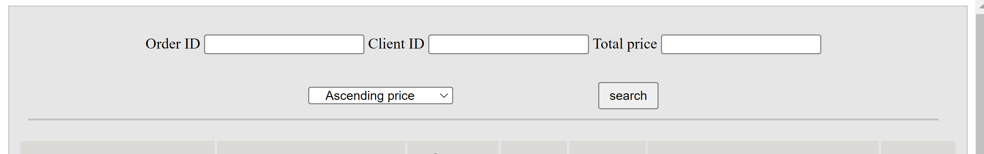

Figure 33 Order Filter

These filtering bars will allow the admin to filter the orders and products on some precise field, for the products data you’ll be able to filter by “Product Name”, “Product ID” and “Stock”, with a filtering by ascending or descending price of product. For the Orders data, the field filter is “Order ID”, “Client ID”, “Total price” and an ascending or descending total order price.

When the search button is press it will get the input from these field and generate a dictionary with the field entry and send to a filtering PHP to gather the filtered data from the database from the input of the user, send back to the JavaScript to be sort and display back in the frontend.

### Remove product and order.

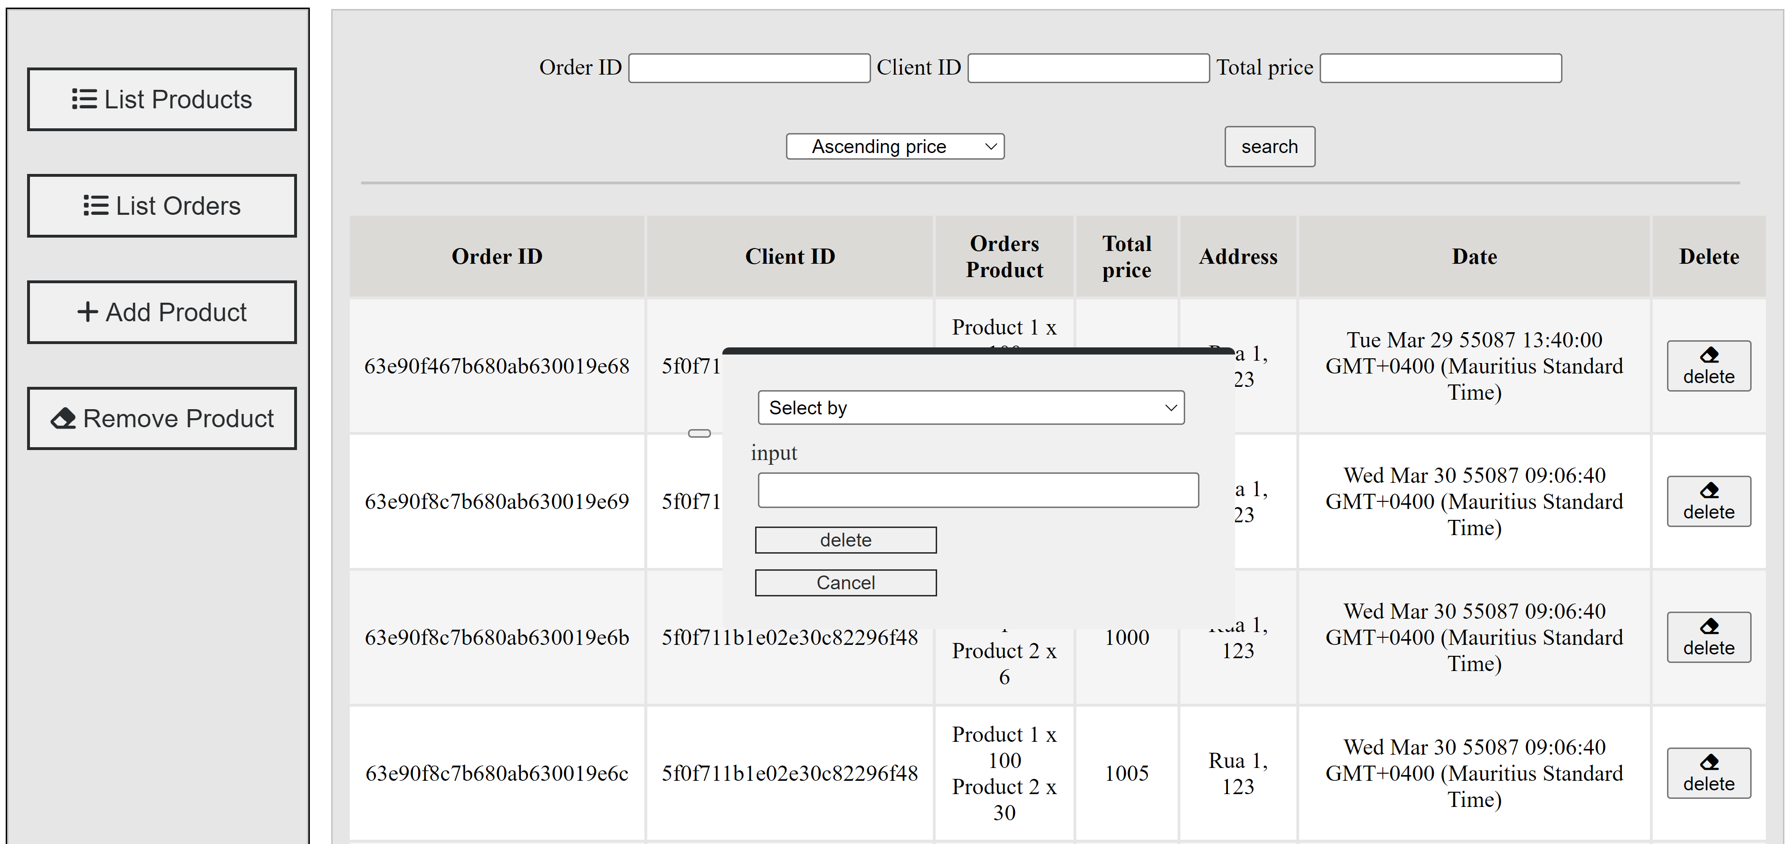

Figure 34 Remove order

The CMS lets the user remove products or orders from the database. To remove a product, the button “Remove Product” will display a dialog where the user will be able to select the selection field (“ID” or “Name”) with the input to enter the information, if the user press the delete button, the selected field with the input will be add to a dictionary and send by fetch to delete_product.php to connect to the database order table and delete the data filter by the user entry and send back the number of lines delete to display an error message if an error occurs, then the table is updated by recalling the last data.

For the cut order option, the user will need to press the button on the left of each row of the orders table. When pressed the JavaScript function will get the row data and use the Order_ID to cut the row with the same procedure by connecting to the orders table, cut the row and update the table.

### Add Product

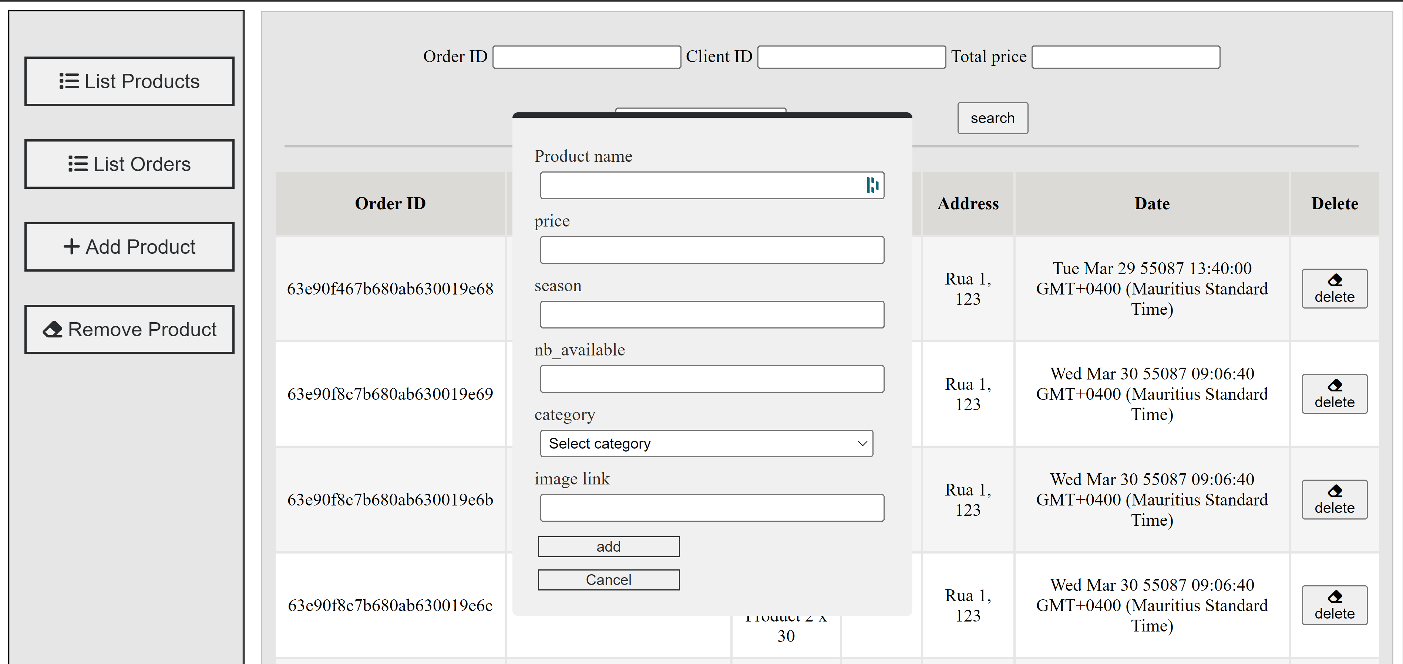

Figure 35 Add product

The “Add Product” button will display a jQuery dialog with an input field for every product attribute except product id (the product id will be generated by mongo DB automatically), if add is press a JavaScript function will take all the different field and generate a dictionary and send it to add_product.php using fetch. Then on the PHP side, the data type of the string and int will be set before inserting the new row into the database, a succeed message will then be sent back to the JavaScript function and refresh the table display with the last updated data.

### Edit product.

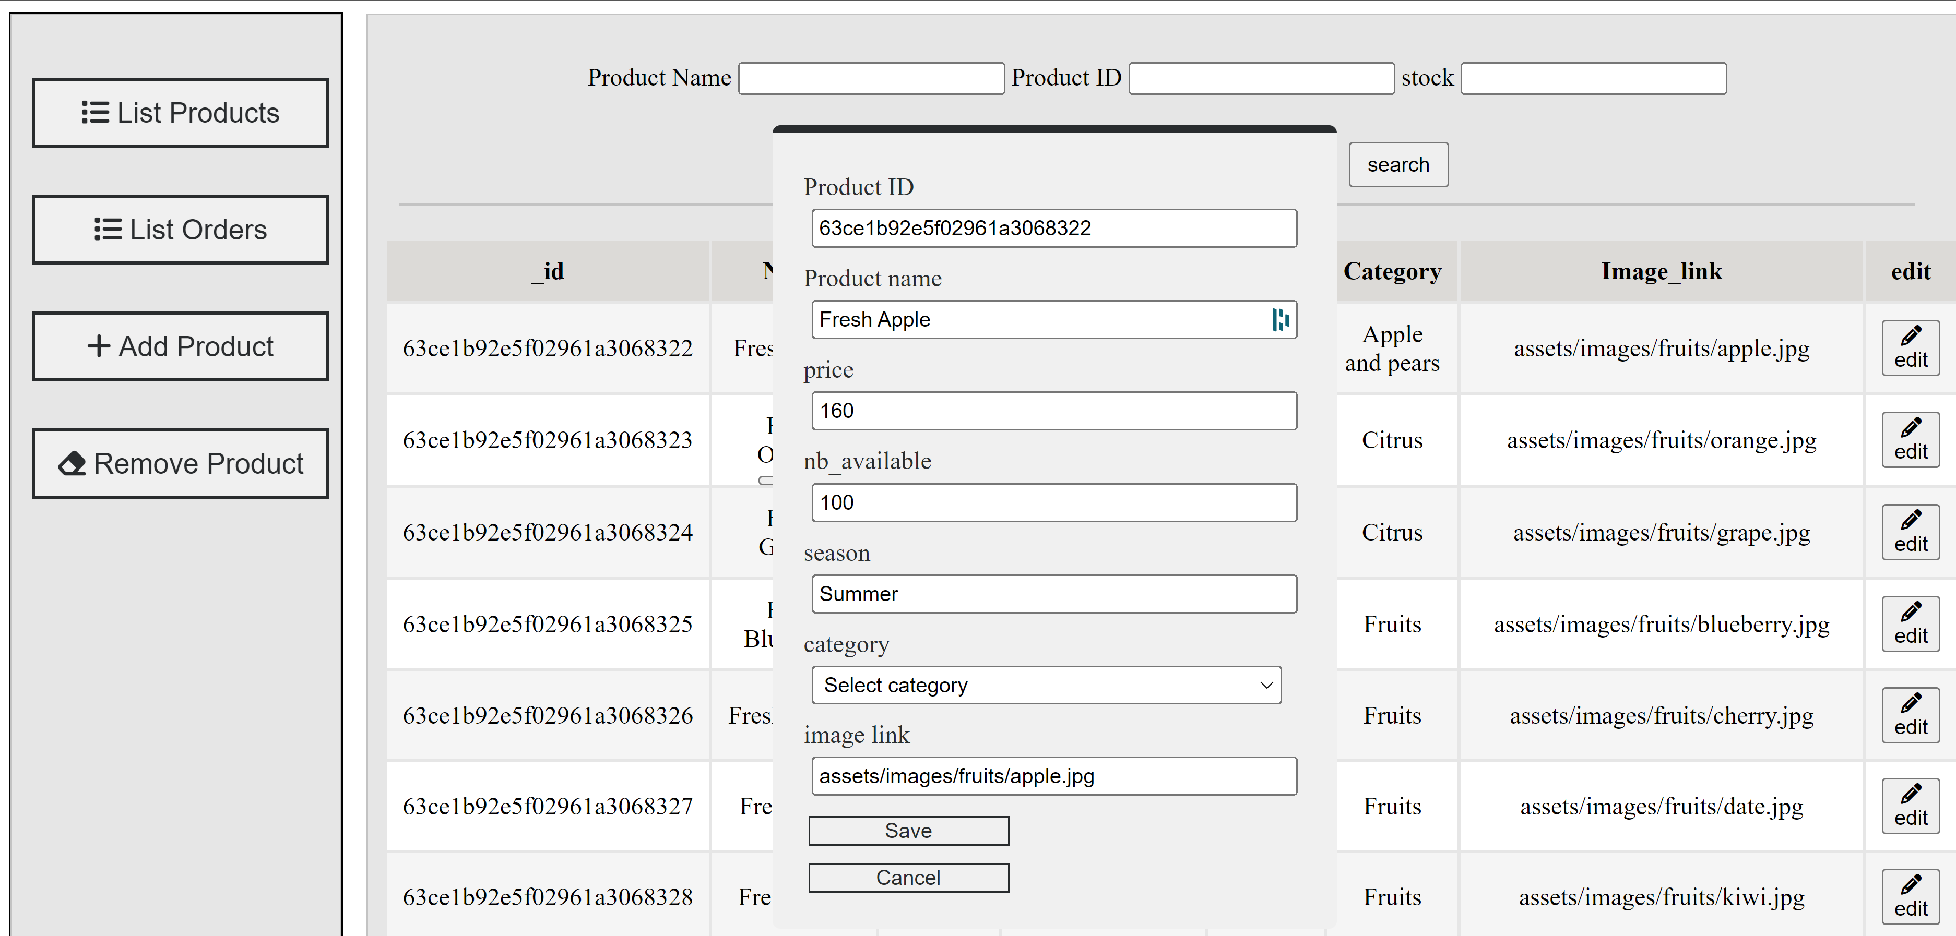

Figure 36 Edit Product

Finally, our last function for the CMS is the product edit function button on the right of each row of the product table. When pressing, a JS function will gather the data of the row to populate a dialog input for each product attribute already fill the data, the user will then be able change them as he wants. Then when the “Save” button is pressed, the data will be set into a dictionary and send to update_product.php using fetch and will update the product using the Product_Id as unique key and send back the result of the modification back to the JS and refresh the table data.

# Security, Privacy and Legal Issues and how they can be fixed?

Since the website is collecting data and accessible to everyone through internet, he is also sensitive to different laws, issue and security problem. On one side since everyone have access to the website and there is a lot of different attacked that could be a thread to our system and our data collected, from these issues come the different regulation with the privacy of the user’s data and finally the different laws protecting them.

## Security

### DDoS Attack:

A Distributed denial-of-service attack or DDoS attack are an important risk for the stability of any website not prepared to it, this attack consist of many simultaneously connection attend to the website in sort of overloading the server setting up the website to make him not accessible anymore. This attack has for purpose to take down a website to make it not accessible during the period of the attack, they usually use many controlled computers by the attacker. This attack can be block by the integration of captcha to authenticate the connection of each computer, some third-party company such has Cloudflare could by integrate to confirm the access of the user with their high-level captcha detection.

SQL and NoSQL Injection attacks:  
An SQL Injection Attacks and NoSQL Injection attack are method us by attackers to bypass some verification by taking advantage of the fact that some verifications are made by directly sending a query to the database using a user input without securing the field enter. For our case it could replace is email and/or password entry with “{$gt: “”}” to get full access of the users presents in the database. To protect the website from this vulnerability, some input verification should be included to detect and avoid malicious input like this one, in our case we use input sanitization protect from this attack, limiting the privileges of the different user to the action they should be able to make will also prevent an unauthorize access with too much privilege.

### Physical Attacks:

Some attack could also be made not through internet but by accessing the website through some material which already have the authorize access such has physical servers or staff computer. By accessing the company or staff local, accessing the material and installing a backdoor on it to keep access or stealing data from it. This attack can be avoided by applying high-level security on the different machines with some access to the servers and database, and by getting some security in the area where the server and the different infrastructure are.

## Privacy

### Data collection:

Our website may gather its users' information for numerous uses in the future, such as market analytics, personalized advertising, and targeted advertising. However, the customers may feel their privacy violated if the website does not disclose what are the data gathered and its uses. To address the issue, we shall provide clear and concise information about the data collected, its use, and with whom the data is shared by including a privacy policy or terms of service and obtaining the consent of the users before collecting any personal data through a pop-up message or a consent form.

### User activity tracking:

Using HTML and PHP session storage, our website helps us monitor user behaviors and gather information about their interest to build our recommendation section. However, some users can find this intrusive, especially if they don't have the option to opt-out. To address this issue we can implement setting or preferences that allows the customers to control how their data is being used or collected.

### Data Breaches:

Users' data may be stolen or subjected to unauthorized access to our website if there are data breaches. This can be particularly dangerous if it involves delicate personal data like credit card information. To protect user data, we can implement the most recent security protocols and tools, such as HTTPS and SSL certificates which can aid in preventing data breaches and protecting user information.

## Legal

### Personal Data:

Since we are collecting the personals data of our website users many laws enter in interference with our collection and in case of data lost in unwanted hands. Many diferent law such has the “Data Protection Act 1998” give the restriction to secured the privecy of the users and give penalty in case and data leak in the web. Some solution may be use to avoid the impact of these leak such has hashing and anomyse senible information.

### Illegal Content:

On the webiste, there’s regulation to respect to avoid the visibiliy of illegal content such has picture that may not correspond to certain people and since it’s a ecommerce website the accecibility of illegal produc. To avoid it, a good knoledge of the law is require and good control of the picture display on the website.

### Abroud data transferts:

When the website got access from another contry of the server where the website is host, some data will be send and receive from these contry and the data regulation may change from the hosting and receiving country, so this echange of data may in some circonstance be illegal. A solution to this issue would be to multiple servers to store the on multiple server to respecte all the differents regulation (or do not declare for security reason to avoid problem).